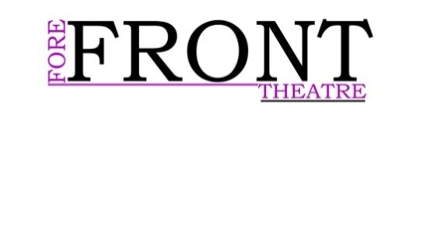
Useful external contacts
Useful to all:
Lincoln BIG—(Business improvement group)
01522 545233
Glynis Fox
Public Relations Manager
glynis.fox@lincolnbig.co.uk

Lincoln Performing Arts Centre
Diane Dubois
diane@lincoln.ac.uk
01522 88 6448

Darren Page
Stage Manager
dpage@lincoln.ac.uk

Box office Coordinator-Phoebe Wall-Palmer
01522 837618
Marketing Manager-Julie Ellerby

01522 837677
jellerby@lincoln.ac.uk

Useful contacts for the Marketing team:
Local media

Lincolnshire Echo
01522 820000
Brayford Radio (Form to fill)
http://www.brayfordradio.org.uk/#!show-proposal-form/c621

The Lincolnite (Facebook)
https://www.facebook.com/thelincolnite

Potential Printers

Chameleon Print

www.chameleonprint.biz
367 High Street
Lincoln
01522 530501

Lincoln Print & Copy Centre Ltd

www.lincolncopycentre.co.uk
Stonefield Park Industrial Estate
9 Clifton Street, Lincoln
01522 546118

Budget Printing Services
www.budgetprintinglincoln.co.uk
219 Winn Street
Lincoln
01522 546488

Popla Print
www.poplaprint.co.uk
2 Newland
Lincoln
01522 532386

Ruddocks Design & Print
www.ruddocks.co.uk
56 Great Northern Terrace
Lincoln
01522 529591

APS PRINTERS

www.apsprinters.co.uk
4A W Parade
Lincoln
01522 525066

Online
Solo press
www.solopress.com/Printing
Vista print
http://www.vistaprint.co.uk/?mk=vesta+print&ad=b&crtv=6070965247&psite=mkwid%7cxMof0VGs&device=c&couponAutoload=1&GP=5%2f25%2f2015+3%3a18%3a15+AM&GPS=3518489042&GNF=0
Instant Print
https://www.instantprint.co.uk/posters?utm_source=bing&utm_medium=cpc&utm_campaign=Posters&utm_term=+poster%20+printing

