Date: 15/05/15 Production: Shoes to Fill Page No: 1
Stage Manager: Emmie Kearns Lighting Designer: Clare Owen
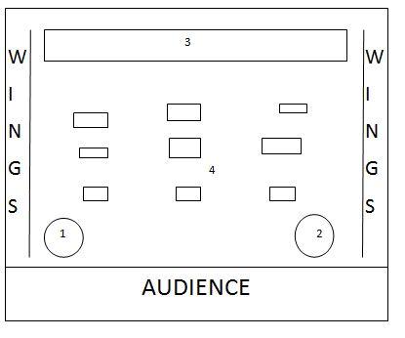
1 –Mic with stand DSR
2 – Mic with stand DSL
3 – Collection of shoe boxes and shoes which do not move for entire performance.
4 – Approx 9 stacks of shoe boxes across the stage. Only present for pre-set and ‘I Want’ Song.

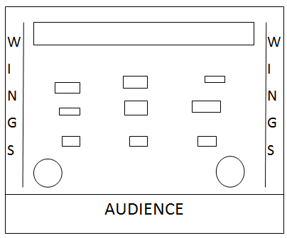
Ch1 (Pre-set)
Purpose: GW
Colour: Lee 103 warm
Unit: Source 4 CP 60 Pars
Intensity: 30
Direction: Covers all of the performance area.
Note: Dim GW to cover the stage whilst audience enter the auditorium.

Ch2
Purpose: DSL Hard Focus Spot
Colour: Lee 201 cold
Unit: Source 4 profiles
Intensity: 60
Direction: DSL
Note: In centre of light must be the 'reality' microphone and stand. Pair of child's shoes to be placed in front of the microphone but still within the spot light.

Ch3
Purpose: GW
Colour: Lee 103 warm
Unit: Source 4 CP 60 Pars
Intensity: 70
Direction: Covers all of the performance area
Note: To light 'I want' song.

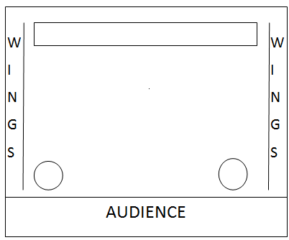

Ch4
Purpose: Strip
Colour: Lee 103 warm
Unit: Source 4 CP 60 Pars
Intensity: 40
Direction: Across width of the stage (DS only)
Note: Strip of light must only light. Hope sat DSC with her box.

Ch5
Purpose: Blackout
Colour: N/A
Unit: N/A
Intensity: N/A
Direction: Covers all of the stage/performance area
Note: Blackout during 'Torches' scene.

Ch6
Purpose: DSR Soft Focus Spot
Colour: Lee 103 Warm
Unit: Source 4 Profiles
Intensity: 60
Direction: DSL
Note: Warm soft focus spot DSR. Mic and stand in the middle of the pool of light.

Ch7
Purpose: Strip
Colour: Lee 103 warm
Unit: Source 4 CP 60 Pars
Intensity: 40
Direction: Across width of the stage (DS only)
Note: Strip of light must only light DS. Hope sat DSC with her box.

Ch8
Purpose: DSL Hard Focus Spot
Colour: Lee 201 cold
Unit: Source 4 profiles
Intensity: 60
Direction: DSL
Note: Clare to perform 'Nurse Verbatim' on mic. Pair of shoes in front of the mic but still within spotlight.

Ch9
Purpose: Pool of light (CS)
Colour: N/A
Unit: Source 4 CP 60 Pars
Intensity: 40
Direction: Covers CS
Note: CS there will be a flipchart. Must be lit well enough for audience to read flipchart.

C10
Purpose: DSL Hard Focus Spot
Colour: Lee 201 cold
Unit: Source 4 profiles
Intensity: 60
Direction: DSL
Note: Luke's interview audio. Pair of shoes will be placed in front of the mic, within the light and taken away by Clare.

C11
Purpose: DSR Soft Focus Spot
Colour: Lee 103 Warm
Unit: Source 4 Profiles
Intensity: 60
Direction: DSL
Note: Warm soft focus spot DSR. Mic and stand in the middle of the pool of light.

C12
Purpose: GW
Colour: Lee 103 warm
Unit: Source 4 CP 60 Pars
Intensity: 70
Direction: Covers all of the performance area.
Note: To light 'Finding the One' song.

C13
Purpose: DSR Soft Focus Spot
Colour: Lee 103 Warm
Unit: Source 4 Profiles
Intensity: 60
Direction: DSL
Note: Warm soft focus spot DSR. Mic and stand in the middle of the pool of light.

C14
Purpose: DSL Hard Focus Spot and Pool of Light (CS)
Colour: Lee 201 cold (HF Spot)
Unit: Source 4 Profiles and Source 4 CP 60 Pars
Intensity: 60 (HF Spot) and 40 (PoL)
Direction: DSL (HF Spot) and CS (PoL)
Note: HF Spot to come up first. PoL will come up on lighting que. HF Spot goes down first and PoL remains on.

C15
Purpose: GW
Colour: Lee 128 Pink and Lee 126 Mauve
Unit: Source 4 CP 60 Pars
Intensity: 70
Direction: GW, covers all of performance area.
Note: Coloured lighting for 'Tinder' scene.

Ch16
Purpose: Blackout
Colour: N/A
Unit: N/A
Intensity: N/A
Direction: Covers all of the stage/performance area
Note: Blackout during 'Footprints' scene.

Ch17
Purpose: DSL Hard Focus Spot and Pool of Light
Colour: Lee 201 cold (HF Spot)
Unit: Source 4 Profiles and Source 4 CP 60 Pars
Intensity: 60 (HF Spot) and 40 (PoL)
Direction: DSL (HF Spot) and CS (PoL)
Note: HF Spot to come up first. PoL will come up on lighting que. HF Spot goes down first and PoL remains on.

C18
Purpose: Strip
Colour: Lee 103 warm
Unit: Source 4 CP 60 Pars
Intensity: 40
Direction: Across width of the stage (DS only)
Note: Strip of light must only light DS. Hope sat DSC with her box.

C19
Purpose: DSR Soft Focus Spot
Colour: Lee 103 Warm
Unit: Source 4 Profiles
Intensity: 60
Direction: DSL
Note: Warm soft focus spot DSR. Mic and stand in the middle of the pool of light.

C20
Purpose: DSL Hard Focus Spot and Pool of Light
Colour: Lee 201 cold (HF Spot)
Unit: Source 4 Profiles and Source 4 CP 60 Pars
Intensity: 60 (HF Spot) and 40 (PoL)
Direction: DSL (HF Spot) and CS (PoL)
Note: HF Spot to come up first. PoL will come up on lighting que. HF Spot goes down first and PoL remains on.

C21
Purpose: Pool of light (CS)
Colour: N/A
Unit: Source 4 CP 60 Pars
Intensity: 40
Direction: Covers CS
Note: Pool must be big enough for 4 performers to spin around in.

C22
Purpose: Strip
Colour: Lee 103 warm
Unit: Source 4 CP 60 Pars
Intensity: 40
Direction: Across width of the stage (DS only)
Note: Strip of light must only light DS. Hope sat DSC with her box.

C23
Purpose: DSL Hard Focus Spot and Pool of Light
Colour: Lee 201 cold (HF Spot)
Unit: Source 4 Profiles and Source 4 CP 60 Pars
Intensity: 60 (HF Spot) and 40 (PoL)
Direction: DSL (HF Spot) and CS (PoL)
Note: HF Spot to come up first. PoL will come up on lighting que. HF Spot goes down first and PoL remains on.

C24
Purpose: DSR Soft Focus Spot
Colour: Lee 103 Warm
Unit: Source 4 Profiles
Intensity: 60
Direction: DSL
Note: Warm soft focus spot DSR. Mic and stand in the middle of the pool of light.

C25
Purpose: Strip
Colour: Lee 103 warm
Unit: Source 4 CP 60 Pars
Intensity: 40
Direction: Across width of the stage (DS only)
Note: Strip of light must only light DS. Hope sat DSC with her box.

C26
Purpose: DSR Soft Focus Spot
Colour: Lee 103 Warm
Unit: Source 4 Profiles
Intensity: 60
Direction: DSL
Note: Warm soft focus spot DSR. Mic and stand in the middle of the pool of light.

C27
Purpose: Pool of light (CS)
Colour: N/A
Unit: Source 4 CP 60 Pars
Intensity: 40
Direction: Covers CS
Note: Sophia's audio and Dr Scene

Ch28
Purpose: GW
Colour: Lee 103 Warm
Unit: Source 4 CP 60 Pars
Intensity: 70
Direction: GW to cover performance area.
Note: Final song.

Ch29
Purpose: Blackout
Colour: N/A
Unit: N/A
Intensity: N/A
Direction: Covers all of the performance area
Note: End of performance.

